Kiwanis Park North Improvements

Public Input Survey

November/December 2022

Contents

1. Background
2. Outreach
3. Survey Results
4. Demographics
5. Emails
6. **Background**

The north side of Kiwanis Park (Baseline Road to Kiwanis Lake) is scheduled for enhancements. Proposed concepts include improvements for the inclusive playground, concessions, and restroom buildings as well as potential designs for a new dog park and other amenities. A public meeting was held on Nov. 19 from 8 to 10 a.m. at Kiwanis Park and a survey was available online at [tempe.gov/Forum](https://www.tempe.gov/government/communication-and-marketing/tempe-forum) from Nov. 4 through Dec. 4, 2022, to gather feedback on the proposed concepts. Over the month of November this survey received a total of 336 visitors and 219 responses.

1. **Outreach**

Several methods were used to provide information to the public and stakeholders regarding the project, meeting and opportunities for input.

Project Webpage

The project [webpage](https://www.tempe.gov/government/community-services/parks/parks-capital-improvements-plan/kiwanis-north-park-improvements) was updated continuously and included information about the project, the date and access information for the public meeting and online comment information. From Nov. 5 – Dec. 5, the website had 493 views.

Top Sources:

* Direct
* Email
* Google
* Tempe Forum
* Twitter
* Facebook
* Spikes:
  + social media posts on 11/16 and 12/3

**Social Media, Eblasts and Press Release**

|  |  |
| --- | --- |
|  | 11/16/22 – Survey/Public Meeting   * Reach: 1,539 I Engagements: 148 I Link clicks: 15   11/19/22 – Come Down to Kiwanis Park   * Reach: 2,656 I Engagements: 329 I Link clicks: 27   12/03/22 – Final Call for Feedback   * Reach: 1,038 I Engagements: 74 I Link clicks: 16 |
|  | 11/15/22 – announcement   * Impressions: 696 I Engagements: 36 I Link clicks: 6   11/19/22 – Come Down to Kiwanis Park   * Impressions: 726 I Engagements: 27 I Link clicks: 6   12/03/22 – Final Call for Feedback   * Impressions: 871 I Engagements: 37 I Link clicks: 15 |
|  | 11/16/22 – Instagram story   * Reach: 489 I Engagements: 4 I Link clicks: 18   11/19/22 – Instagram story   * Reach: 587 I Engagements: 1 I Link clicks: 1   12/03/22 – Instagram story   * Reach: 572 I Engagements: 2 I Link clicks: 20 |
|  | 10/21/22 – Survey closes soon   * Impressions: 2,819 I Engagements: 3 |
|  | 11/16/22 – Survey/public meeting   * 5,871 emails sent, 36.2% open rate, 1.2% click rate, 85 clicks on survey link   11/17/22 – Survey/public meeting reminder   * 5,865 emails sent, 32.1% open rate, 0.5% click rate, 50 clicks on survey link   11/28/22 – Tempe This Week newsletter inclusion   * 7,944 emails sent, 39.5% open rate, 5.1% click rate, 30 clicks on survey link |

Direct Mailer

Two direct mailers were sent to residents near Kiwanis Park. The boundaries were Baseline Road to the north, Guadalupe Road to the south, Rural Road to the east, and Kyrene Road to the west. The first direct mailer included a brief overview of the project and details on how to attend the public meeting and provide comments. The second direct mailer was a reminder to provide comments.

Yard Signs

Yard signs with meeting and comment information were placed in Kiwanis Park.

Emails

A notification email was sent to Tempe Forum subscribers, neighborhood contacts, relevant Boards and Commissions and previous participants in Kiwanis Park outreach inviting them to attend the meeting or to comment online.

1. **Survey Results**

The survey was available online at tempe.gov/Forum from Nov. 4 through Dec. 4, 2022 to gather feedback on the proposed designs for improvements for the inclusive playground, concessions, and restroom buildings as well as potential designs for a new dog park and other amenities.

146 respondents provided an address with approximately 90% in Tempe.

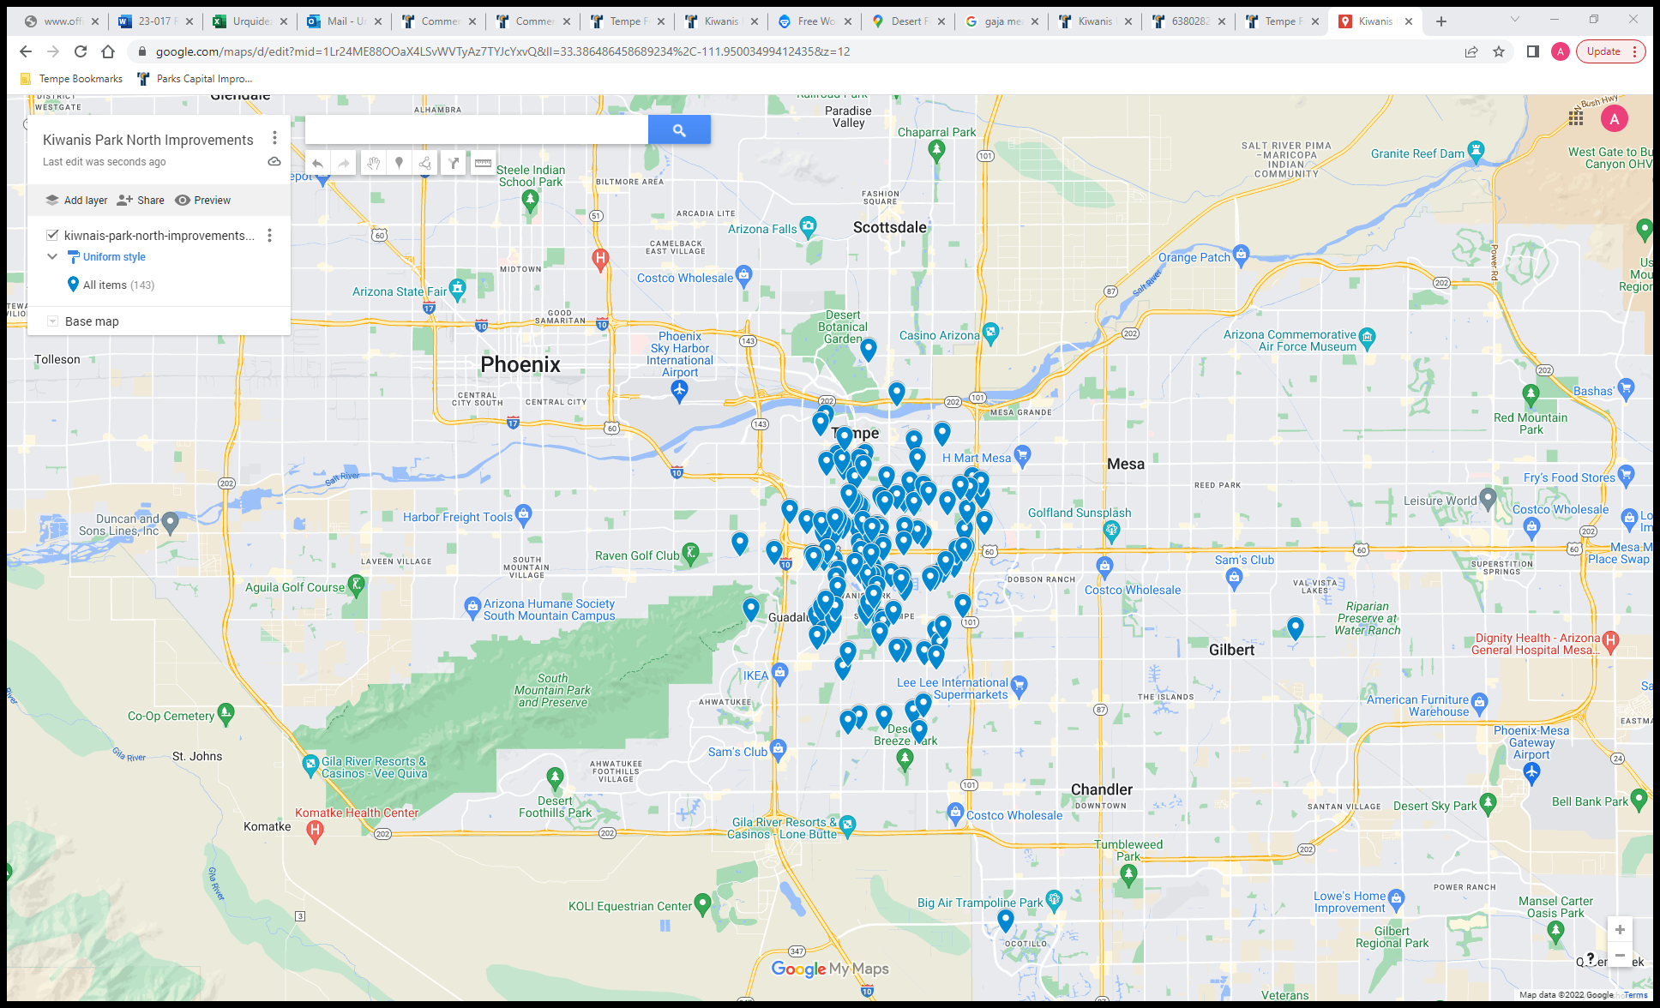

1. **Do you live within a mile of Kiwanis Park?**

Responses: 218

1. **How often do you visit Kiwanis Park?**

Responses: 219

1. **What amenities do you use when you visit the area between Kiwanis Lake and Baseline Road? Select all that apply.**

Responses: 214

Other Comments:

* All paths
* baseball fields
* basketball court
* bathrooms
* Batting cages
* bike paths
* bike routes
* Field
* general areas for walking and photography
* Grass areas
* grassy area for dog walking
* have had picnic lunch and breakfast
* I walk from the ballpark parking and do laps around the lake
* I walk my dog all over the Park, getting at least 7 miles in each visit.
* I would use the volleyball courts more if they were better
* indoor pool/gym area
* open green space
* open park areas
* park walking path
* Path around lake
* path around the lake and throughout the park
* Paths around the park
* paths around the park with my workout group - Fit4mom
* Picnic in hills surrounding lake
* ramadas and grass areas
* ramadas and grass areas
* Restrooms
* Restrooms
* Restrooms
* Restrooms
* Sand Volleyball
* shaded, grassy areas for dog to cool down in
* sidewalk loop
* sidewalk/ track around lake
* Sidewalks and trails for walking
* Sidewalks around lake and plants, trees, turf, ramadas, etc.
* Swimming pool
* The perimeter of the park for walks or runs
* the shade and green spaces of the park in general
* Trails, paths, trees for birding
* Volleyball courts
* walk
* Walk around lake or entire park area.. since COVID and because the play area is always filthy (and sketchy folks are hanging out I havenâ€™t used in several years
* Walk dogs around the lake, or all the way to soccer fields.
* Walk the dog around the lake, park, playground, fields
* Walking
* walking my dog
* walking path
* walking paths
* walking paths
* walking paths
* Walking paths
* walking paths
* Walking paths, trees, water fountian

1. **If you could improve one amenity in this area of Kiwanis Park, what would you improve?**

Top 5 Amenities:

1. Restrooms/Bathrooms (30)
2. Playground (22)
3. Dog Park (11)
4. Improved Paths (11)
5. More Trees (7)
6. A bridge or crosswalk across Baseline for people using the canal path.
7. A dog park and restroom upgrade
8. A playground that is more thrilling. It's pretty good but it's a big park. See: pioneer park in mesa
9. Add a dog park
10. Add a dog park
11. Add a dog park!
12. Add a dog park, add to the concession/boating area, continue to keep clean
13. Add a large dog park
14. Add exercise / activity stations.
15. adding a dog park
16. Adding a dog park and restrooms
17. addition of a dog park
18. Area between parking and concessions is a little rough. Enhanced landscape would help.
19. Bathroom/concession area
20. Bathrooms
21. Bathrooms
22. bathrooms
23. Bathrooms
24. Bathrooms
25. Bathrooms
26. Bathrooms to individual rooms not a shared room for individual security.
27. Bathrooms; more local art/murals
28. Benches & some of the slope grade
29. Better bathrooms.
30. Better dedicated paths across Baseline Road
31. Better integration of the canal path and the park. There are only 2 entrances connecting the canal path and the park
32. better restrooms and water fountains
33. Better ways to cross baseline to get into park for pedestrians
34. Bicycle Racks; We will bike with our dog to new dog park. - as a first class feature
35. Boat concessions, playground on north side
36. boating concessions
37. Bocce ball courts
38. Canal path
39. canal path cleanliness, lighting on the west side especially
40. Change the turf area north west of the lake to Baseline to a desert botanical garden paths, lighting, and identifying placards.
41. Clean up area around lake/bathrooms/playground area.. upkeep of grass area /open the concession to evening time..
42. Clean, well-maintained restrooms with doors on the stalls, and soap in the soap dispensers.
43. Cleanliness
44. Concession and bathrooms
45. Concession area seems unused and old
46. Concessions
47. Dedicated bicycle paths
48. Dog area
49. Dog park
50. Doors on bathrooms
51. Drinking Water Access
52. Eliminate homeless problems
53. Ensure fully functional The Cloud water features, audio, light. Add a separate covered section of the cloud for smaller children to play, they get mowed over by older kids.
54. Expanded splash pad area
55. General facilities including reducing homeless population
56. Get rid of the homeless it's trashing R. City and bringing down the value of our homes
57. Get the homeless ppl out.
58. Grass areas
59. Have more workable water faucets. A lot of them around the lake don't work
60. I would add a Disc Golf course.
61. I would create a dirt path next to the existing lake path so I don't have to run on the sidewalk
62. I would like to see yhr playground become more inclusive
63. I'm a huge fan of desert landscaping and shade. I'd walk the path more year round if I could get more beautiful xeriscape and not just lawn through the path until it hits rocks.
64. Improved fields for sports activities
65. Kids playground
66. Lake
67. Lake
68. Lake. It's been gross lately with lots of dead fish.
69. Landscaping
70. Lighting
71. Love the dog park idea
72. Maintaining the new things that we added - the splash pad features are often broken
73. Make a dog park for small dogs
74. Make playground better suited for kids older than 4.
75. Make several areas in the dog park that's fenced off. A dog run area I think would be a great very big great benefit to big dogs who don't really want to be around other dogs for a little dogs who are terrified of big dogs
76. Make the entire park just a little less car centric. I only visit by bike and getting around the park is confusing. car
77. More basketball courts, night time lighting
78. More bathrooms
79. More bike paths
80. more community events, food trucks
81. More drinking fountains for dogs
82. More natural shade over walking paths, even more greenery
83. More potable water spigots along the walking path and near the canal entrances.
84. More private areas for ducks. People bother them too much.
85. More seating
86. More shade trees
87. more shade- trees- flower and vegetable gardens
88. More sustainable landscaping/green spacing that can help cool down the park and its visitors
89. More trash cans
90. More trees
91. More Trees
92. More trees and native plants
93. More trees and shade
94. More trees, workout equipment
95. More trees.
96. More walking trails.
97. More water fountains with dog bowl geature
98. More/better water fountains; we should have recycling and compost bins in addition to trash cans; better lighting for night time use- it's scary to be there in the dark.
99. N playground
100. None
101. North playground floor and equipment is outdated and falling apart.
102. Parking
103. Parking lot
104. Play ground equipment and expand playground Rea
105. Playground
106. playground
107. Playground
108. Playground
109. Playground
110. Playground
111. Playground
112. playground
113. Playground
114. Playground
115. Playground and bathroom
116. Playground equipment appears very old and dated and there is usually a broken/closed slide.
117. Playground Should be accessible to people with disabilities
118. Playground, restrooms
119. Probably the splash pad. It was cool when it went in but is paled by those in Chandler/Gilbert now. I've never seen the boat rentals be open - it would be cool to have those be more accessible.
120. Put a dog poop bag dispenser on the south east soccer field (by Guadalupe rd)
121. removing the homeless
122. renovate restrooms
123. Restroom and Parking lot
124. Restroom areas
125. Restrooms
126. Restrooms
127. Restrooms
128. Restrooms
129. Restrooms
130. Restrooms
131. Restrooms and concessions
132. Restrooms and concessions area
133. Restrooms for sure!
134. Roller hockey rink
135. Rose garden hasn't been tended to since volunteer moved several years ago. Make upkeep a staff job
136. Running and biking trails
137. Safety
138. safety of using the canal path
139. Safety, nicer grass and less trash
140. Security
141. Security. Lots of homeless loiterig, and unleashed dogs.
142. Shade and grassy areas
143. shade to walk around the lake
144. Shaded seating near playground
145. Signage to designate the park areas
146. Snack bar area
147. Some more shade, and places to sit, pet watering stations
148. Splash Pad
149. Splash pad
150. Splash pad improvements
151. splashpad
152. Synthetic turf. Get rid of the grass. More Trees.
153. The bathrooms
154. The cloud
155. The concession building
156. The lake
157. The lake
158. The lake
159. The lake honestly. It always sort of smells.
160. The lake itself
161. The playground
162. The playground
163. The playground
164. The playground
165. The Playground
166. The playground equipment.
167. The walking/biking bath
168. Today I walked my dog for 2.5 hours and saw ELEVEN off-leash dogs in the Park. Please start enforcing the Leash Law in the Park.
169. Update the play area. Have more ramadas. More park security presence, there are a lot of homeless people in the park. Makes parents uncomfortable.
170. Updated amenities
171. Upgrade restrooms
172. Upkeep on rose bushes
173. Urban camping, it's become a huge issue and deters families to other parks.
174. Use less water, cut down grass in favor of other landscaping
175. Vegetation and walks. Please prohibit motorized traffic on walkways and separate bikes from walkers. Walks are cracked due to erosion, lack of care. Trees are dying.
176. Volleyball courts are in major need of an upgrade
177. Walk way around the lake
178. Walking paths
179. **What amenity or features could be added to this area of Kiwanis Park that would draw you in to use the space more frequently?**

Top 5 Amenities:

1. Dog Park (52)
2. Playground (8)
3. More trees (6)
4. Pickleball (5)
5. Canal Path (4)
6. A better playground and a ramada that accommodates a large party of more than 40 people
7. A bridge or crosswalk across Baseline for people using the canal path.
8. A dog park
9. A dog park
10. A dog park
11. A dog park
12. A dog park.
13. A lot more trees and shade
14. A more convenient way to access the canal path from the paths around the lake, more shade, water bottle filling stations
15. A more interesting playground, maybe more events
16. A playground accessible to people with disabilities.
17. A safer place to spend time in
18. A splash pad for more age groups.
19. A walking path, with workout equipment. An active sport area for all ages similar to parks in Mesa. A climbing attraction for children.
20. Accessible playground equipment inclusive to all abilities
21. Add a dog park!
22. Add exercise / activity stations.
23. Add pickleball courts
24. addition of a dog park
25. Better bathrooms more movies in the park
26. better concessions
27. Better lighting at night for field areas
28. Better playground space that is secure
29. Better sense of satefy in parking lots after dark
30. Better shade- it gets too hot under the current shaded area. More shaded areas for adults to sit.
31. Bigger kids playground
32. Bike parking, more colorful landscaping and cleaner sitting areas
33. Children's amenities that are in better condition and repair, cleaner, and more attractive.
34. Cleaner bathrooms
35. Cleaner facilities
36. cleaner playground, bird deterrants
37. Cleaner water
38. Concessions
39. Deeper/softer sand and easily adjustable nets (pin and slider type)
40. Definitely a dog park, and more public art
41. Definitely a dog park, I currently go there to walk or run with my dog around the lake and through the nearby neighborhood and along the canal path
42. Definitely native vegetation, xeriscape vegetation, flowers, and seasonal variance.
43. Disc golf
44. Disc Golf course
45. Disc Golf course
46. Disc Golf course
47. dog park
48. dog park
49. Dog park
50. Dog park
51. Dog Park
52. Dog Park
53. Dog park
54. dog park
55. Dog park
56. Dog park
57. Dog park
58. Dog park
59. dog park
60. Dog park
61. Dog park
62. dog park
63. Dog park
64. Dog Park
65. Dog park
66. Dog park
67. Dog park
68. Dog park
69. Dog park
70. Dog park
71. Dog park
72. Dog park
73. Dog park
74. Dog park
75. Dog park and more dog bag stations.
76. Dog park and Skate Park Pump Track
77. Dog park or dog area, exercise machines
78. Dog park with amenities, especially water features to help my dog cool down
79. Dog Park, with first class features.
80. Dog park, improve concession area and keep it open more frequently
81. Dog park.
82. Dog park; skate park; better playgrounds
83. Dog stations, More poop bags, dog water fountains
84. Emergency stations like a light post one could push a button to alert emergency responders. Have community events that are low cost or free.
85. Enclosed dog park where dogs are free to run around and updated concessions and bathroom area
86. Fog park
87. Food and Bathrooms
88. Food truck space / community activity space
89. Garden, art
90. Grass that is green
91. High level playground
92. I like it how it is. It's open space. It's a rarity in Tempe now
93. I would love to see a dog park/area!
94. improved splashpad and playgrounds
95. Improvements
96. Include pickleball courts
97. Increase tree shade coverage of paths.
98. Install work out stations
99. Interactive art installations/interesting things to photograph
100. Keeping some usable open space
101. kids playground along with kids programming
102. Larger playground that allows kids to have more interactive equipment to explore as well as with adult exercising stations nearby so you can keep an eye on your children. Enclosed playground for infants to 3yr olds.
103. Leash free dog park
104. Less sketchy people living in cars or in the park
105. Lighting
106. Maintain a feeling of nature.Don't make the park one big playground and no space left to be in nature
107. Make a dog park for small dogs
108. making the dog park free range like the south soccer fields so they can run and run and run
109. marking distance walked in miles, more water fountains for animals and children
110. more attention paid to the rose garden and better grass
111. More benches along the canal path.
112. More bike paths and locks
113. more connecting bike paths
114. More lighting for safer night time walking
115. More natural shade over walking paths, even more greenery
116. more parking or entrances
117. More pet friendly
118. more picnic areas and maybe a community garden- beer garden area run by private vendor
119. More seating
120. More seating in grass around the lake.
121. More shade
122. More shade
123. More shade
124. More shade trees
125. More trees
126. More trees and native plants
127. More trees, plants, safe areas for urban wildlife. Safer and cleaner restrooms. Play equipment for all ages.
128. More trees, workout equipment
129. More walking trails.
130. More water recreatio
131. Movie events, community festivals
132. My dog has been attacked by off leash dogs and we have both been injured. I am at the point of stopping coming to the Park because of the huge number of off leash dogs all over the Park.
133. New playground, indoor pickleball
134. New, cleaner play structure for ages 5-11
135. Ninja equipment
136. No lose dogs remove the homeless
137. None
138. None, please repair existing walk, vegetation, slopes etc.
139. Not so much dog poop. I used to walk my puppers there several times a week, I need to do that, I like the well lighted area better than my neighborhood, it's too dark in spots.
140. Obstacle course
141. Organized events in the secret park. Things like food truck events, pop up shops etc. Vendor fees could offset any additional cost for events.
142. Outdoor exercise equipment
143. Outdoor exercise equipment such as pull bars, sit up benches etc.
144. Pickeball Courts
145. Pickle ball court
146. Pickleball courts
147. Pickleball courts!!
148. plant more trees & add a pickleball courts
149. Play equipment for older kids
150. Playground for adults. Larger swings, climbing ropes or silks, gymnast equipment. Small kids are not the only people who stay fit and have fun by playing and small kids already have all the options. I would visit a Tempe park daily if it were equipped for fun for adults.
151. Refreshed ramadas
152. Roller hockey rink
153. Satellite bus service
154. shade
155. Shade
156. Shade covering
157. Shade structures, water fountains
158. Shade trees
159. Shade Trees and Turf
160. Sidewalk repairs, clean the park, weed eat by the sidewalks, rake the rocks
161. Skate Park
162. Skate park
163. Skate park/ pump track
164. Sustainable landscape with shade, nature trails, and artwork.
165. Swings, more play things like Margaret hance park in phx
166. Tennis courts, pickle ball courts, garden, dog park
167. The car shows were great. This area is also used for running events.
168. This is from a city park in St. George Utah and would be wonderful addition to the Splash Pad area. https://www.sgcity.org/citysquares/townsquare
169. Train
170. Tree
171. Umbrellas shade
172. Updated bathrooms
173. Updated bathrooms and covered playgrounds and ramadas
174. Updated playground equipment more benches/Ramadan for parents and caregivers to sit at es
175. Updated ply areas and updated lake pavilions
176. Water feature (wading/fountain?) adults could use too. I'm embarrassed when I have to run under kids fountain to get wet :)
177. We need a dog park, preferably with one area set aside for smaller dogs, also some shade and benches for owners. Needs to have water fountains for both.
178. Well lit running and biking trails
179. Xeriscaped butterfly garden
180. zip line, etc closer to the playground on the other side of Kiwanis
181. **Which of the below activities do you value most in parks?**

Responses: 215

1. **From the list below, please select the five (5) most important items that should be part of the park Improvements.**

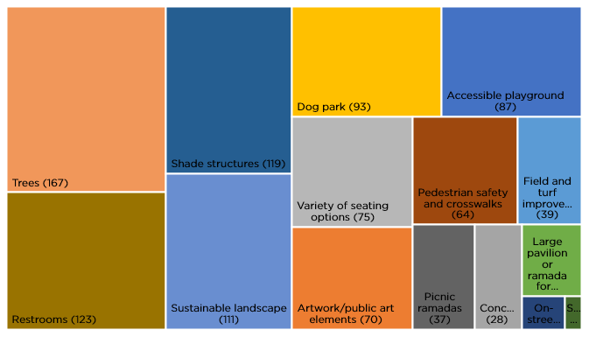

Responses: 216

Other comments:

* Bathrooms are so important to me, as I'm older. I also hate stainless steel toilets without a proper seat!!!
* Conversion of he large turf area to educational desert landscaping.
* Disc golf course
* Disc Golf Course
* Disc Golf Course
* Disc Golf course
* Do not add or change anything
* I beg you to enforce the Leash Law, lose dogs are a threat to leashed dogs and their owners. I know because my dog has been attacked several times by off leash dogs resulting in injuries to both my dog and myself.
* I'd like some of the least used paths and concrete areas removed and add turf and trees. Please do not add DG to the park.
* No homeless ppl
* Will ask my dog owning family about dog park designs.All of above are wonderful ideas. We can make all happen, first choice since I will not live to enjoy all is Walking trail. In my 79th year and my partner is in his 89th. Kiwanis is our health place.

1. **What components of play do you think are important to consider when developing the play area? Select your top 2.**

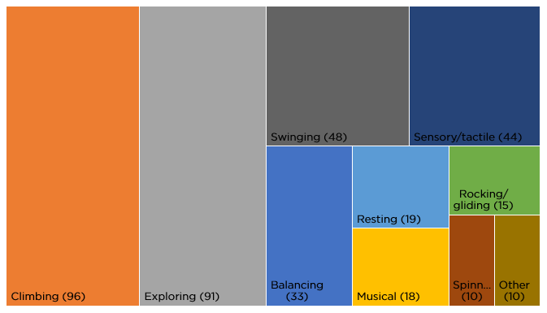

Responses: 194

Other comments:

* Accessibility for all levels
* Active seniors who love walking, sidewalks are trip hazards, takes months/ years for repair requests to materialize, lots of erosion, desire dying trees to be replaced and motorized vehicle prohibited and bike and walkers separated.
* Anything as long as all access needs are considered.
* Fitness
* For Adults
* leave it alone
* playground for seniors
* sliding
* sliding
* The Cloud is such a great place for children and I feel very important to keep. Children like to swing, spin, slide, discover - all that is inclusive. The Cloud is the best splash pad in the area - I realize both options include the Cloud, please keep!

1. **How do you feel regarding a dog park in this area?**
2. A big YES! Suggestions: Separate Large dog area, at least twice size of small dog area. Add dog washing areas, each with three walls and leash clip. Add perimeter walk path, with occasional benches inside dog area. Add dog water splash and wading area inside dog zone. Add dog obstacle course and playground.
3. A dog park would be a nice addition
4. A dog park would be amazing!
5. A dog park would be great!
6. a dog park would be great.
7. A dog park would not improve this park. Dogs can be loud and smelly and bring a different energy. The park should be focused towards sports, recreation, families and rest. I enjoy Kiwanis for the recreation on one side and peaceful relaxation on the other. Consider optimist park for a dog park instead.
8. About time!
9. As long as it is cleaned up daily /multiple times and safe for non users.
10. Awesome. Love it.
11. Bring in more people, which will hopefully move the homeless camp that is in that area
12. could be improved
13. Definitely in favor of a dog park. So many people have dogs with limited places for their dogs to be off leash and run.
14. Definitely needed.
15. Doesn't matter to me
16. Dog lovers but not a fan of dog parks.
17. Dog parks are fine
18. Egh not excited
19. Eh, dog parks are over rated. I'd rather have paths to walk. People unfortunately make dog parks suck cause they don't monitor their dogs.
20. Excellent addition
21. Fine
22. Fine
23. Fine about it
24. Generally not a fan of dog parks.
25. Good
26. Good
27. good but could be better if there is one for more active/larger dogs, and one for elder/small/less active dogs
28. Great idea
29. Great idea!
30. Great idea! I think every city park should have a dog park or off-leash area that would be enclosed as a separate place for pets to enter-act with other pets.
31. Great idea! Parking may be more difficult - but love the idea of a dog park there.
32. Great idea, as long as the area's upkeep is constant
33. GREAT idea, especially since it will be at an extreme end of the park and away from central park activity.
34. Great the homeless will love that. View problems on neighborhood app. It's too dangerous for regular ppl.
35. Great!
36. Great!
37. Hell yeah dude
38. I am all for it
39. I am in support of an area for dogs to run free and play together,
40. I am not sure
41. I believe it's a good use of this space.
42. I do not have a dog. I hope it is designed to prevent unleashed dogs from escaping.
43. I do not know much about dog parks but there are a lot of people who walk their dogs around the lake so I would think it would get some use.
44. I do not own a dog but the park draws dog owners and there is a clear benefit to better utilize the north lawn that is mostly unoccupied.
45. I do not see the need for one.
46. I don't have a dog - so it is not a priority for me.
47. I don't have a dog and my child is terrified of dogs. Keeping dogs in one location away from the playground is a good idea.
48. I don't have a dog myself but the friends who have dogs I know would love a dog park. I think it's a great idea.
49. I don't have a dog, so I have zero interest. If a dog park was installed, I would recommend making it physically separate from the children play and water parks. The dog park shouldn't just be a fenced-off field, it should have play features for the dogs and owners to engage with... And there should be resources to ensure leash laws are observed
50. I don't use them, they have too much poop in them. I like to walk my dog in the winter. I also like well lighted paths.
51. I feel great about it!
52. I feel it would be very popular and widely used. But I do not have a dog.
53. I feel like this is a bad idea. Dog parks are naturally restricted spaces. Keep it open as it is.
54. I feel like this is long overdue
55. I feel positively about having a dog park, provided it doesn't interfere with community events like soccer games that take place at the parks.
56. I feel this will cause more problems with dog's attacks and issues between dogs owners. Plus more dog poop in the park
57. I haven't used it
58. I love dogs so much, but dog parks can be dangerous, especially with all the kids around. I don't think a dog park at Kiwanis is a good idea.
59. I love the idea! There is a ton of space for it and I have 2 pups that would love it!
60. I love the idea.
61. I personally do not use Dog Parks because the one time I stepped into one with my large dog, another dog came running at him growling and the owner just stood there. I had to back the oncoming dog off. However since the Dog Leash law is not being enforced in the Park perhaps a Dog Park would lower the number of loose dogs in the Park thereby increasing safety for dogs and owners who respect the Leash Law.
62. I really don't prefer a dog park
63. I think a dog park would be a good use of the space, but I probably would never use it just because I live south of the park and it would be a very long walk from the south side to the north side just to use a dog park.
64. I think dog parks are overrated, and often done wrong, If there is a dog park, it should have small- & large-dog (gentle/calm & active) enclosures. At the other dog parks in Tempe (done wrongly), all it takes is one out-of-control dog to ruin it for everyone who isn't there to celebrate high-energy dominance, etc. Having said that: I've always thought the sunken grass area at the south edge of the lake (extending beneath the bridge) would make an excellent dog park. It's kind of wasted space. The shade of the bridge would be useful for that purpose. But, I don't think that space is large enough for designated calm/active (small/large) enclosures unless such could extend south of the bridge somehow. (Note: I wouldn't differentiate entirely small vs large dogs. It's about the dog's energy, the owner's expectations for the dog's behavior. There are big dogs who would do well (and be welcome) in the "small-dog" enclosure. And, there's out of control small dogs who would fit better in the "large" enclosure. It's not about size as much as the owner's leadership and expecting their dog to have manners.
65. I think dog parks can be very nice amenities for some people and I would not be opposed to a dog park at Kiwanis. However, I would be very unlikely to use the dog park with my dogs, because of concerns about the rise of unvaccinated animals and concerns about other dogs' behavior (my oldest dog was attacked by another dog, when she was peeing outside: this resulted in her needing emergency surgery and since she is 10.5 years old, I don't want to put her at risk). That being said, while I do not use dog parks, I think dog parks can be a great opportunity for others.
66. I think it could be great as long as it is well-maintained and regulated. I would want aggressive dogs' owners to be reprimanded and removed if necessary.
67. I think it is a good idea
68. I think it is a good use of space and needed in the area.
69. I think it should have an agility course for dogs, i.e., equipment for dogs to play through tunnels, poles to walk through, climbing things, hoops, jumping over poles, etc. as well as areas for dogs to fetch a ball, and a place to cool off in the summer like a little pond that has good aeration and draining.
70. I think it would be a wonderful addition!
71. I think it would be awesome!
72. I think it would be great. I loved the Barking Bodega because it was regulated with vaccine records required and no aggressive dogs. They had employees and guests had to pay which made it great. I know a city ran dog park might not be able to have that dynamic but I encourage you to reach out to the previous owners of the Barking Bodega to consult with. Chapparel Dog Park in Scottsdale has their park separated by “passive” and “active” dogs as opposed to size. I like that concept as well. A larger dog may be old and mellow so wouldn't fit in with other active big dogs.
73. I think it would be terrific adjacent to the green areas of the park. As long as it didn't reduce the amount of green space.
74. I think it would help give dog owners a dedicated space for their dogs to play.
75. I think it's a wonderful idea provided it will be well maintained.
76. I think my friends from Phoenix would visit me more often if Kiwanis had a dog park.
77. I think my friends would enjoy it.
78. I think that would be wonderful!
79. I think this is a good idea
80. I think this would be a great enhancement to the park!
81. I worry for the safety of small children near a dog park
82. I would live it.
83. I would love a nice, shady dog park with water features (splash pad, hose features, etc.) to give dogs a space to run around and enjoy splashing around in the water. This summer season felt long, and my dog was stuck inside for almost all of it because there were so few places she could go and keep cool.
84. I would love an off leash dog park
85. I would love it
86. I would love it very much.
87. I would love one!
88. I would really like it. So long as it is keep cleans and deorderized frequently.
89. I would use it if there were a few agility structures for small dogs
90. I would welcome it.
91. If it keeps dogs off play structure, great.
92. If it keeps dogs off the playground where my kid plays, great.
93. I'm fine with a dog park. Probably a good idea.
94. I'm ok with it, but it seems very large. Also I am strongly opposed to removing the grass on the edges of the park and replacing it with DG, Leave the grass ALL THE WAY TO THE EDGES.
95. I'm open to it. But there needs to be more leash law signs.
96. Impartial or neutral
97. Indifferent
98. Indifferent
99. Indifferent
100. Indifferent.
101. Indifferent.
102. It is a good idea
103. It needs to have a environmental friendly poop disposal area the kind that's in the ground that you sprinkle some things on and then it turns back into armless Earth. I'm sick of having plastic bags as a convenience to everyone and a problem for the environment.
104. It would be a great idea and would attract more people. There are already so many great amenities so this would make Kiwanis that much more inclusive.
105. It would be a great improvement.
106. It would be great
107. It would get me to go more.
108. It's a big park. A dog park would be great! But it should be tucked away from the playground. I'm tired of having to be on defense w dogs on the playground.
109. It's a great idea!
110. It's fine with me. Gives a good off leash option for dog owners.
111. LOVE IT
112. Love it !!!!
113. Love the idea
114. Love the idea. My dog and I go regularly to walk and run, and dog park would be a very nice addition.
115. May be a good addition depending on what current activities would be eliminated.
116. Meh
117. Meh.
118. Most Definitely! So many people have dogs here but no parks so yes please
119. Most walkers have dogs, we do not. We love the benefit of dogs to human mental health. Bravo for idea of a dog park. Please prohibit the motorized vehicles, small children, unsupervised race around without helmets. Danger to themselves and others. Disrupts serenity. Make a scooter park somewhere else. Also need to maintain current art on canal, maybe add a par course, much erosion and disrepair. Water valve covers broken, not maintained, sprinklers broken for months after being reported. A valley jewel in great disrepair. So sad.We can do better. I want to help.
120. My dogs don't like dog parks, but I think this would be a great use of the space and a great amenity in Tempe/at Kiwanis
121. N/A
122. NA
123. Na
124. Needed
125. Neutral
126. neutral
127. Neutral. I would be more inclined to take my dogs to a dog park that has a separate area with agility equipment so the owner and dog can engage in something different and interesting together.
128. Nice but I live near others
129. Nice to have a designated area away from young children for pets to be off leash vs a free for all as it is now
130. No
131. No because it will attract more homeless people with dogs. This means more dog waste.
132. no issue
133. No opinion
134. No proben
135. No thanks
136. NO- we have plenty
137. No!
138. Not a dog owner
139. Not a fan of dogs or a dog park. I prefer no dog park. If there must be one keep the dogs away from kids, and the smell and hygiene of dog pee, poop, vomit and hair is a large concern. I don't want to be down wind and ruin my visit at the park with an odorous stench. My grandkids are afraid of dogs, especially when they see a large dog. A large distance away from children play area is preferred. A high fence in case a dog can jump over fence.
140. Not important at all
141. Not in favor of dog parks at all. Too many people in the Kiwanis area already have dogs off leash when they shouldn't and are not responsible dog owners. I work with several dog trainers and none of them recommend dog parks. I have two dogs and never take them to a dog park. Dog parks are too high of risk for injury to dogs and people, too high a liability for the City. Individual dog runs (for letting the dogs run and chase balls) would be much better.
142. Not too excitef
143. Not unless it were gated.
144. Ok
145. ok but enclosed, away from playground
146. Personally, has someone with poor experiences with dogs I suppose I don't have much of an opinion.
147. Please build one
148. Please only put a dog park if there is going to be enforcement of the leash law around the park.
149. Poor. The dog parks that I have seen in the surrounding parks are seldom used and the amount of unscooped poop makes the areas unusable for anything other than a dog park. I'm all for dogs and love taking my dogs through the park almost daily. I think Kiwanis is a great place for a dog as it is already.
150. Positive
151. Positive
152. Rather see investment in improved maintenance of existing infrastructure and landscaping
153. Sounds great
154. Strongly in favor
155. STRONGLY PRO. I would love for Tempe to add a dog park that includes agility equipment. This central area would be perfect!
156. strongly support
157. Supportive
158. Supportive
159. Sure, it's fine
160. Take it or leave it-
161. That would be an awesome addition.
162. That would be great. Would be awesome if was designated between small and big dogs.
163. That's a big no for me. The park already draws a crowd that barely follows the rules and I think adding a dog park to the mix is not a good idea. Can't wait to hear about a pit bull mauling-.
164. The area is pretty bland and boring right now. Could use some dog friendly structures
165. The northwest corner of the park seems like a good place for it. We have children and don't have a dog, so we'd like there to be a place for dogs to have their own space that won't interfere with children.
166. There are plenty of dog parks in Tempe. I do not feel we need one at Kiwanis .Many people walk their dogs daily at the park.That hill where the dog park is proposed has a beautiful stand of trees dedicated in 1989 to commerate the bicentennial of the US Constitution. It's a nice quite place to stop and enjoy nature of which there is less of in Kiwanis as it turns into an amusement park. Share nature with people activities and let the dog walking remain.
167. There should be a separate area for dogs under 16 lbs. People don't pay attention if their dog is attacking another dog - especially if the other dog is small.
168. This feels long overdue
169. This is needed. Always see dogs here and park needs a safe area for them
170. Too many people have their dogs off leash in the park. I wonder of a dog park would alleviate this issue, or compound it by attracting more people who will have their dog off leash. If it would alleviate it, and not impose on the walkers, relaxers, picnicers, I would be in favor.
171. Very nice addition in the area proposed.
172. Very positive. Much needed amenity!
173. We don't have any pets o don't have a valued opinion
174. We would love a dog park!
175. What a nice addition! There isn't one nearby that's public otherwise
176. Would be nice to have a dog park. Would be better to have fully stocked dog excrement bag stations throughout the park.
177. Would be very useful
178. Would love a dog park here.
179. Would rather not
180. Would suck
181. Wouldnt care for
182. YES
183. Yes but please make sure it's safe if next to baseline. Busy road!
184. Yes dog park would be a good thing
185. Yes dogs are part of the family and a dog park would be a great addition to this wonderful park!
186. Yes I want it
187. yes one is needed
188. Yes please
189. Yes please!
190. Yes!
191. Yes!!
192. Yes, dogs and cats need a space to play
193. Yes, it needs one
194. Yes. Would be great
195. Yes-it's needed in this neighborhood
196. **Would you prefer a separate area for small or young dogs?**

Responses: 211

1. **Which concept do you prefer for the dog park layout (west of Ash Ave.)?**

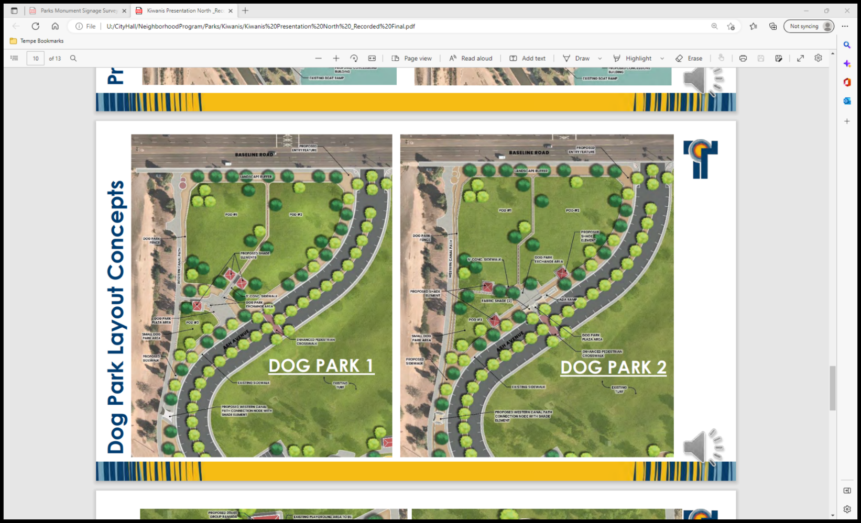

Responses: 180

1. **Which concept do you prefer for playground and restroom concession area?**

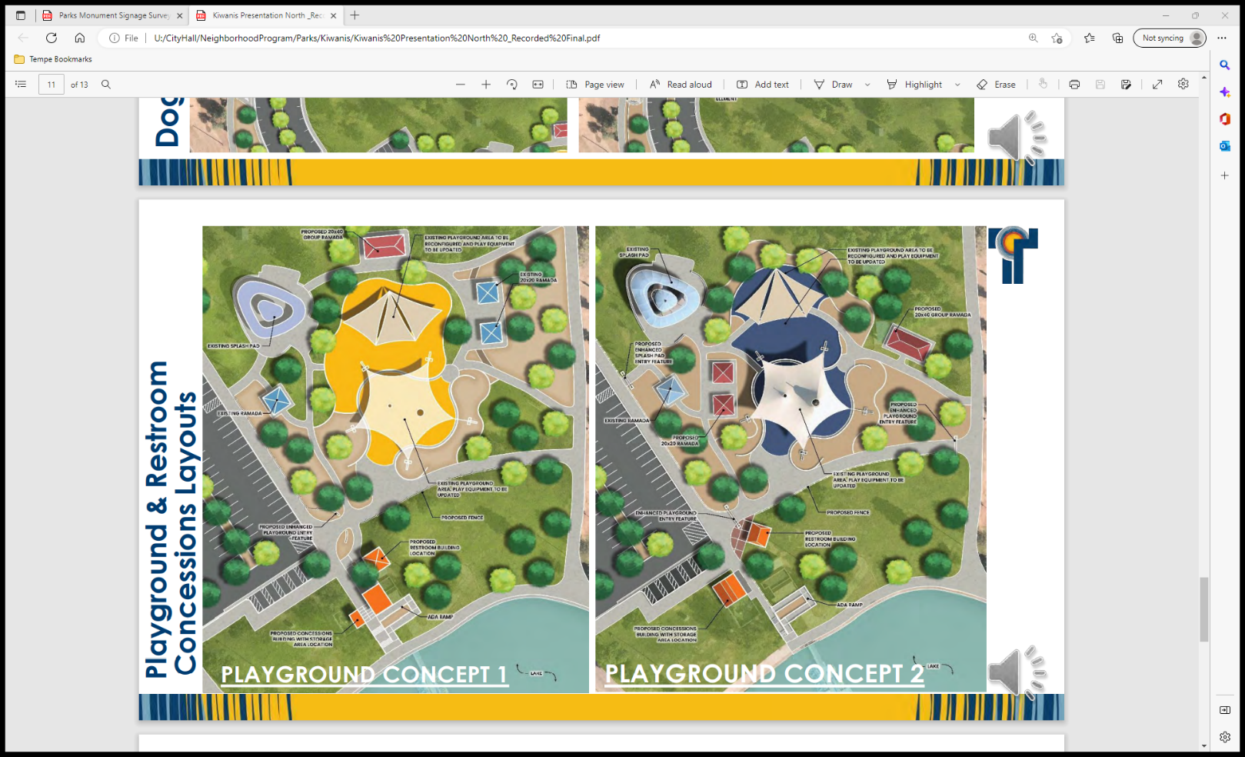

Responses: 185

These plans show the development of a new dog park area for this section of the park. In the future, the entire park may be eligible for additional amenities. The number, type, and size will be determined by funding and fit.

1. **Please select the amenity you would MOST like to see in Kiwanis Park.**

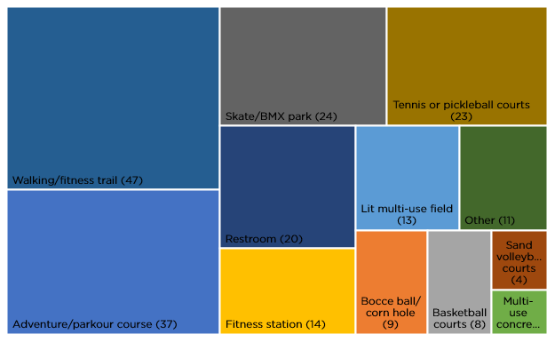

Responses: 213

Other Comments:

* Bathrooms are so important to me, as I’m older. I also hate stainless steel toilets without a proper seat!!!
* Conversion of he large turf area to educational desert landscaping.
* Disc golf course
* Disc Golf Course
* Disc Golf Course
* Disc Golf course

Do not add or change anything

* I beg you to enforce the Leash Law, lose dogs are a threat to leashed dogs and their owners. I know because my dog has been attacked several times by off leash dogs resulting in injuries to both my dog and myself.
* I'd like some of the least used paths and concrete areas removed and add turf and trees. Please do not add DG to the park.
* No homeless ppl
* Will ask my dog owning family about dog park designs. All of above are wonderful ideas. We can make all happen, first choice since I will not live to enjoy all is Walking trail. In my 79th year and my partner is in his 89th. Kiwanis is our health place.

1. **Please select the amenity you would LEAST like to see in Kiwanis Park.**

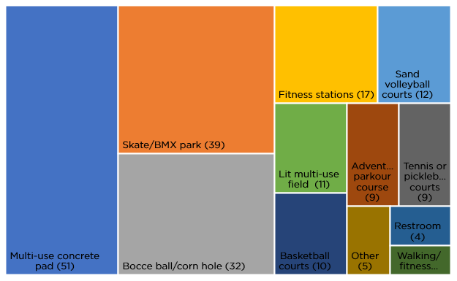

Responses: 202

Other Comments:

* Disc Golf Course
* Do not change anything at the park. Do not add anything.
* Dog park
* Frozen Banana Stand
* I can’t choose - they are all good ideas

1. **Additional Comments**

Top Five Themes for both suggestion/concern

1. Dog Park/ Leash Law (9)
2. Trees (6)
3. Open green space (4)
4. Skate park (3)
5. Cleanliness/maintenance (3)
6. Add more trees
7. Additional Pickelball courts would be nice as there are none located in the central part of Tempe.
8. bird deterrents and shade structures are important features for our young family
9. Bocce ball and corn hole are great but the balls/bags disappear frequently making the set ups rather moot.
10. Cleanliness is what matters most and it needs to be cleaned now. The parks cleanliness should not be put off. The sidewalks are dirty with duck poop and very gross, the bushes and trees are overgrown, and the rock areas look dirty. We would were surprised to see there is currently zero upkeep. The community is still using the park.
11. DOG PARK
12. Dog park should not be so close to the main road, somewhere more centrally located with more space would be better. Need to have lots of shade as well.
13. Dog park. Yes please
14. Fitness stations would be great but the ones with moving pieces don't hold up well. I would love to see ASU industrial design/architecture/landscape architecture students create solid structures/statues that could be utilized for body weight exercises. Designers love making chairs and this is would be pretty close!
15. Green spacing is becoming increasingly important in the valley. I'd love to see more of this with sustainability and native plant populations in mind. Thank you for continuing to solicit feedback from us!
16. Hard to understand difference between layout options, maybe a description along with layout graphic would help us understand the difference and intention of the differences.
17. Have you been to the park, it's ripe with lose dogs and homeless drug addicts.
18. I am sorry to carry on about the enforcement of the Leash Law in the Park however when I saw eleven loose dogs in 2.5 hours today at the Park I became anxious and thought "why am I paying taxes to support a Park that I used to love but am now afraid to walk my dog in?" Thank you for listening to me.
19. I believe we have plenty of lit field options already. Adding a skate park would allow locals to use Kiwanis for skating in a designated area, not use the existing sidewalks for practice, and not require them to drive to the Tempe Skate
20. I do not see the need for a dog park.
21. I feel that it is important to have some open spaces throughout the park just for the sake of some open space...for events like the Ride a Wave Car Show, or just for laying in the grass. I also feel that a dog park is important to give the dogs a place to run that is fenced in.
22. I like that playground concept #2 has removed some of the unnecessary grass around that area, but prefer the slight more space between the 20 x 20 ramadas with playground concept #1.
23. I love Kiwanis and am excited for these updates! My biggest hope is for an easy way to access the canal paths from the area around the lake-right now it involves walking up a hill or through bushes, and a clearer way to access the trail would be really nice.
24. I suspect a restroom near the dog park/children's play area would be an additional benefit.
25. I would like to see more trees, native plants, and less concrete. Take into consideration the heat and try to create an environment that is cooler. Add natural elements as much as possible. Maybe even reduce the parking areas and encourage more biking and walking to the park.
26. I would love to see a place to hold events like weddings and other events.
27. I would really like a Disc Golf Course in this park.
28. If a skatepark is installed, it needs to accommodate roller skaters and bladers as well as skateboarders. Any surface installs should be permeable and/or reduce the heat island effect of the site! Be wise and your material choices.
29. Is the dog park a done deal?
30. Kiwanis park is fine just the way it is. If you have money, our money, burning a hole in your pocket, why don't you return it to the tax payers instead of looking for ways to spend it?
31. Kiwanis was very obviously built with cars in mind. this is not bad but bikers and pedestrians are somewhat excluded. would love to see more integrated bike and walk paths... maybe similar to the greenbelt in Scottsdale. It is also oddly hard to access the canal paths, would love to see improvent there.
32. Making improvements to our parks is a waste of money as long as they parks are going to be used as de facto homeless shelters. A place for the houseless to be MUST be a part of any improvement plan to the parks or else people will continue to avoid them.
33. More trees, at all the parks.
34. Pickleball courts, Disc Golf course. Bocce Ball, and a fitness course/trail.
35. Pickleball is the fastest growing sport in the US. Kiwanis ia a perfect location for it.
36. Please keep shade in mind for playground. Also parking for dog park and only having 1 pod may be cool. Skatepark for future would be super Tempe. Thanks for all that you all do!
37. Please keep this park green and shaded. I understand the sustainability issues, but creating more DG and concrete areas INCREASES the heat. In Tempe Public Parks I really want turf and trees.
38. Please make sure the public art is integrated, not plopped into the design. Have the artist be a meaningful part of the design team.
39. Sand volleyball courts are a huge use of water in our drought! Should be made and used sparingly. There are others at other parks already that are underutilized.
40. Sand volleyball courts are in MAJOR need of an upgrade. They should be brought up to a similar quality level as Indian school park and scottsdale ranch park in scottsdale. If there were 8 or more quality courts here in Tempe, it would get a ton of use.
41. Sister City Gardens needs to be repaired and maintained.
42. Skate park or pump track would be good pump track is good fore a wide spread age group
43. Skate/BMX parks are always popular for that teen demographic that is difficult to serve. Kiwanis is so much more accessible from other areas of Tempe than the Sports Complex, teens can skate there directly from the canal pathway! Give teens a safe place to convene, to exercise, to socialize, to learn. And if you outfit it with AMAZING public art, concessions, and a restroom, it will be the ultimate destination!
44. Sorry I missed the meeting - thank you for this option to add my opinion!
45. Thank you for caring about our preferences and what would benefit our families the most. We feel heard and cared about :)
46. Thank you for this survey. We have lived in kiwanis park 10 years come March 2023. Never seen a single person use the southeast volleyball courts by the wave pool. Please consider doing something there! Also if making a dog park please consider having a long stretch of field for the dogs to run similar to the southern soccer fields. One last thing please consider some type of discount for residents in kiwanis to use the gym or facilities. Can't justify the price and would love to support it but it's way more expensive for less equipment than nearby gyms.
47. Thank you parks department for your survey! Appreciate y'all trying to improve Tempe. Keep it up.
48. Thanks for accepting these surveys. I live near Kiwanis and very much want to use it, but I don't mind it that different from my local park so I won't make the drive. However there is lots of space to stand out and I think a really good xeriscape could do that, but it's the will of all people, not just mine. Thanks for listening!
49. Thanks for creating this survey! I love that the City of Tempe values our opinions and actually uses our taxes to benefit the community.
50. The biggest issue we face right now are the homeless. We need to get rid of campers. Makes trash, germs, and a feeling of unsafe area to be. Don't waste $$$ in making things better if you can't keep the homeless and crime out
51. There is not sufficient parking for large events.
52. This is very exciting! I'm so happy to see the plans for the playground. The elevated play structure was really scary when my children were young since it's easy for them to go off the sides. I'd also recommend considering the pigeons roosting on the lights under the shade structure. They make a really big mess (as pigeons do), but it's unfortunate to have that mess right in the middle of a small play area.
53. To try help with the heat island issue is to add trees next to every sidewalk or roadway. So, suggesting it would be nice to see additional trees added to the entire length of the west, north and east side of the park. Adding trees to the grass area west of the proposed concession building in concept 2 along the sidewalk next to parking lot. Adding picnic tables or benches west of the proposed concession building. Suggesting adding a traffic table where the crosswalk will be installed to keep traffic speed to a minimum. Lately, if irrigation changes are scheduled for watering the grass next to sidewalks please do not use multi-stream sprinkler heads. Majority of the existing ones that were installed a couple years ago at this park don't work.
54. very much looking forward to the dog park
55. Walking a fitness trail. And lots of shade.
56. We love Kiwanis park and were here before there was a Kiwanis. It is used primarily by those who would identify as minority, African American, Asian, Hispanic. Maybe there needs to be a focus group with the families and fisher persons and elderly who are the primary users of the park. Kiwanis may be our most diverse example of gathering in Tempe. We also have a consistent and growing homeless population in the park. Seems like who ever developed this survey has not spent any time in the park in the last decade. We love our community and care deeply for it and value this opportunity to provide spontaneous observations. I would like to be involved in more impactful opportunities to make Kiwanis the treasure and jewel of our community it once was. I did not see anything on the list to provide opportunities for social services for those in need who spend their days taking shelter there. An aside, I love the herons, geese, ducks, and what is left of trees during this extended drought. Am always tempted to pick a rose on the southwest end of park. They are not covered with invasive vines. Loved ball fields to south while raising grandchildren. Loved the pool and tennis courts but pickle ball is new wave. Vote for all that any will enjoy and have which have health benefits. We are blessed to live in Tempe.
57. We need more Leash Law signs in the park. I like the dog park idea too.
58. While Kiwanis Park already has a tennis center, those courts are not truly public or accessible. Adding two actual public tennis courts to the park would prove to be very productive.
59. Your pool and pool staff are amazing!!! Keep it up but we would appreciate more lap times
60. **Demographics**

The City of Tempe wants to better understand how well it is serving community members. Collecting demographic data allows the city to effectively plan and distribute its programs and investments. The collection of data provides a more precise picture of current Tempe residents and businesses. Providing this information is highly encouraged and helpful to the city, but it is not mandatory.

**Race:**

Responses: 197

Other – mixed:

* Other - Does it matter
* Other - human being
* Other - Japanese/white mixed
* Other - Middle eastern
* Other - Mixed
* Other - None
* Other - Two or more

**Age:**

Responses: 208

**Gender:**

Responses: 202

**Do children in the following age groups live in Tempe with you?**

Responses: 243

**How did you hear about this survey? Check all that apply**

Responses: 207

Others:

* Logged in for another Forum survey
* My boyfriend
* My spouse
* Nextdoor
* Nextdoor
* Nextdoor app
* Online
* Reddit
* Reddit
* Reddit
* Reddit Tempe
* Reddit Tempe page
* Tempe forum
* Tempe Forum webpage
* Tempe Reddit
* Tempe Website
* This webpage
* Word of mouth from partner.
* Newsletter
* Signs at the park

1. **Emails**
   * + 1. **Nov. 9, 2022 -** I have lived at my home since 1973, before Kiwanis Park was a park. My wife (Vicki) and I raised our two children here with them going to Aguilar and Marcos. We enjoy early coffee out front (we have a front yard patio) in the morning and sunsets in the afternoon. We are both retired having worked hard all our lives to live in Tempe where we do. Enough about us. The reason for this letter is about the homeless directly across the street from our house. They have taken over the Ramada across from my house. In the morning a lot of times there is trash spread all over the hill between us and the Ramada. They park junk cars over across the street and sleep in them. One morning we woke up and found a hooded sweatshirt in one of our planters. We have seen drug deals go down, reporting it some time ago. At the entrance to the park there are signs stating that the park is closed at midnight, are we enforcing this. We are thinking about security cameras, but would like to think we shouldn’t have to do that. I’m usually not a complainer but growing very unhappy with what we see. Thank You. I would really like to know your thoughts.
       2. **Nov. 17, 2022** - [https://www.beverlyhills.org/departments/communityservices/cityparks/lacienegapark/lacienegaoutdoorfitnesspavilion/](https://protect-us.mimecast.com/s/8vTXCERy08InAO5QTNxF0A?domain=beverlyhills.org/) PLEASE NOTE ATTACHED LINK FOR IDEAS FOR KIWANIS PARK RENO
       3. **Nov. 29, 2022** - thank you for all the work you’re doing to make updates to this park. Our family has enjoyed it for many years, playing at the playground with niece and nephew when they were little, to seeing them play soccer and do high school races through the pathways. My dad and I have walked the paths, admiring the birds and social life of Tempe. As an elder advocate and a creative artist and provider of programs for people living with dementia, I advocate for  the inclusion of a stage/amphitheater space for outdoor activities (for all ages) with shade. There is a kind of stage along the right side of the lake that might be revamped, or to consider integrating a new space on the north side improvements. If I can speak with someone, I’d be glad to share this vision and its value to the community.