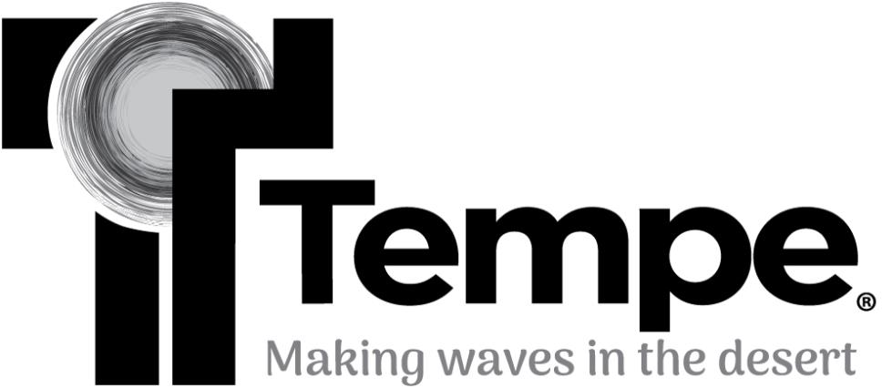

PUBLIC MEETING AGENDA

Human Relations Commission

Tuesday, December 10, 2024
6:00 p.m. – 8:00 p.m.

In-Person
Tempe Public Library - 2nd Floor Cottonwood Board Room
3500 South Rural Road, Tempe, AZ 85282

Virtual
Microsoft Teams meeting
Join the meeting now
Meeting ID: 255 874 213 928 Passcode: 8xvSrZ
Or call in (audio only)
(480) 498-8745, Phone Conference ID: 994 057 109#
Notice of Meeting
Pursuant to A.R.S. § 38-431.02 notice is hereby given to the members of the Human Relations Commission and the general public that the Commission will hold a meeting open to the public on Tuesday, December 10, 2024, at 6:00pm for the purpose of discussing matters on its agenda.

This meeting will be held virtually through Microsoft Teams. Public comments may be submitted to Velicia McMillan Humes by email, velicia mcmillan_humes@tempe.gov or phone, (480) 350-8970, no later than 5:00 p.m. on December 9, 2024.

Native Land Acknowledgement Statement: We wish to acknowledge that Tempe is the homeland of the Native people who have inhabited this landscape since time immemorial. These ancestral lands of the O’odham (known as the Pima), Piipaash (known as the Maricopa), and their ancestors extend far beyond our city. This land continues to be spiritually connected to the O’odham of the Salt River Pima-Maricopa Indian Community and Gila River Indian Community. We accept the responsibility of stewarding those places and solemnly pledge to consider this commitment in every action.

MEETING AGENDA

- Public Appearances
The Human Relations Commission welcomes public comment at this time. There is a five-minute time limit per person. ** Please note we encourage the community to attend, participate and contact us. If we can assist or partner with you on an issue, we ask you to place the topic on the agenda for the next meeting. In this way, the Commission will serve notice to the community of our discussion, consideration, and possible action on the topic. Please feel free to speak with any Commissioner or Commission staff member so we may assist you.

- Approval of Minutes: HRC – November 12, 2024

- Youth Engagement on Human Relations Commission: Commissioners will discuss a proposed method to formally include youth engagement on the HRC through MYAC representation. Discussion and possible vote. (15 minutes)

- Promoting Unity in the Community: Regional Unity Walk – Saturday, January 25, 2025
Staff will provide information concerning strategies for utilizing the Regional Unity Walk to promote community building. Discussion and possible vote. (10 minutes)

- Public Arts Plan
Public Arts Manager will present information concerning the upcoming Public Art Plan and scheduled outreach. Discussion only. (15 minutes)

- Dr. MLK Jr., Annual Diversity Awards Breakfast – Monday, January 13, 2025
Staff will provide status updates i.e. nominations received, propose dates for nomination reviews, sponsorship opportunities, and provide event specifics. Discussion and possible vote.

- Announcements
The Commission may make announcements regarding programs or current events that are not on the agenda. Neither discussion nor legal action will be taken regarding these announcements.

- Upcoming Meeting Date and Proposed Agenda Items
Commissioner may make suggestions or recommendations regarding future agenda items for the chairperson to review and priorities. Discussion may take place; no legal action will be taken.

According to the Arizona Open Meeting Law, the Commission may only discuss matters listed on the Commission agenda. The City of Tempe endeavors to make all public meetings accessible to persons with disabilities. With 48 hours advance notice, special assistance is available at public meetings for sight and/or hearing-impaired persons. Please call 350-2905 (voice) or 350-8400 (TDD) to request an accommodation to participate in a public meeting.

