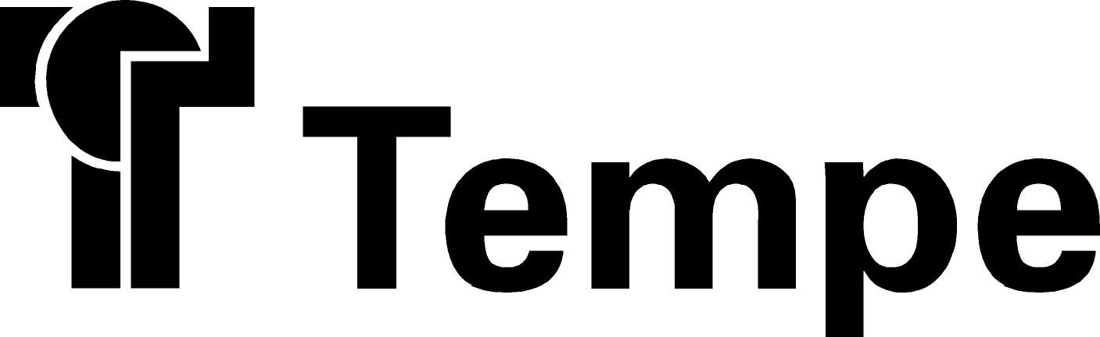

Minutes of the Neighborhood Advisory Commission (NAC) held on February 4, 2015 5:35-7:00p.m., at Tempe History Museum Community Room, 809 E. Southern Ave., Tempe, Arizona.
DRAFT Minutes
Neighborhood Advisory Commission
February 4, 2015

(MEMBERS) Present: Karen Adams, Nancy Buell, Kiyomi Kurooka, Nancy Lesko, Josephine McNamara, Robert Miller, Julie Ramsey, Joaquin Rios, Christopher Ware.

(MEMBERS) Excused Absences: Arlene Chin, Cole Hickman, Matt Korbeck, Bill Munch, Russ Plieseis, Scott Smas.

City Staff Present: Elizabeth Thomas, Neighborhood Services Specialist; Shauna Warner, Neighborhood Services Director

Guests Present: Joe Livingston, Tempe Resident and Tempe Arts Plan Steering Committee Member; John Kane, Tempe Resident and Tempe Arts Plan Steering Committee Member; Christina Kucera, ASU Walter Cronkite School student.

Agenda Item 1 – Call to Order
The meeting was called to order at 5:35 p.m.

Agenda Item 2 – Public Comment
There was no public comment.

Agenda Item 3 – Consideration of Minutes: January 7, 2015
Commissioner Ramsey made a motion to approve the January 7, 2015 minutes and Commissioner McNamara seconded the motion. The motion passed unanimously.

Agenda Item 4 – Tempe Arts Plan
Tempe Arts Plan Steering Committee Member Joe Livingston and John Kane stated that the city had hired consultants to look at arts in Tempe (encompassing visual art, performance art, public art and writing) to help determine what direction we want to go in the future. To this end, they are going out far and wide into neighborhoods and the community seeking as much input as possible. The minutes from this commission meeting will be shared with the consultants as well.

Commissioners were asked to complete hard copy surveys and/or to go online to www.tempe.gov/tempeartsplan to do so and to encourage all their Tempe neighbors and contacts to fill out the survey as well. Mr. Livingston posed the following questions (in bold italics), commissioner feedback is noted below each question:

With regards to arts education and lifelong learning, what do you think is the state of art in education?
- Minimal at best
- The arts that are taught are specific to and relate to academics only
- Wish there were more opportunities for children to partake
- Sub-optimal at best
- Little to no funding or attention paid to the arts
- Arts education was very important and enriching to me up through high school, it saddens me that these options often don’t exist anymore.

We’ve been hearing there needs to be more funding. If we take that off the table, what other ideas might you have?
- Break away from all this common core
- Make art part of K-12 education
- City is not in control of schools nor does city fund art education in schools. We should be having this conversation with the school districts.
- Not everything needs to be in schools or through schools, it’s too limiting, go beyond the school districts
- Public art needs to be more visible
- Art in parks
- Pop up art
- Art shows
- Art contests
- My child is special needs, limited offerings and I have to attend also. Not even one offering for her age group through Tempe parks and recreation.
- No table at the town hall specific to public art funding only. It’s two different conversations, one is about art itself and one is about funding and money.
- No public art in South Tempe. There are literally two Tempes – North Tempe and Suburban Tempe. There should be art everywhere.
- Neighborhoods like Maple Ash have received multiple neighborhood grants. They know what to do and how to do it and are successful at it.
- Integrate art into all development agreements.
- Kiwanis Park is a huge opportunity.
- Need a Tempe Friends of the Arts Foundation – not specific to TCA.

What about TCA? What are they doing well and what are they not doing?
- Not most visible or convenient place to access
- Too far of a drive from my home
- This is a destination location, need a reason to go
- Good job getting some different acts
- I’m not drawn to it.
- 4th of July dinner and party was great

Do we have enough facilities?
- Need outdoor community band stand or stage
- Poor parking options at Tempe Beach park
- Gammage and TCA are sufficient
- Mesa Arts Center venue is much better for outdoor activities and performances
- Want summer performance opportunities – places for locals/kids acting, singing or dancing groups to perform
- Tempe High School has huge fields that aren’t used in summer
- Empty/closed school repurpose options

What arts programs are available for children and families?
- ASU’s Museum Saturday Fall Arts Programs
- Tempe History Museum offerings
- Parks and Recreation classes

Are city programs as robust as they need to be?
- No, limited offerings
- Would love textile, finger painting, collages, clay or found art classes for children

Where is a good location?
- Pyle
- Partnering with schools over summer break – does not need to be a school sponsored program
- Traveling arts in park programs
- Need make it and take it locations

How is Tempe different?
- Arts Festivals with kids booths
- Educated population
- Enclosed/land locked
- More stable population, many long term or choice residents
- Reputation for more liberal, open and involved residents
- “I think of anywhere in the Valley, Tempe is looked to and expected to be invested in the arts.”
- Pride in Tempe, perception that quality of life is better here.
- Schools, culture, progressiveness, art is key to all

The Tempe Arts Plan is currently in the information gathering stage. All comments and survey results will be compiled by the consultants and a draft plan is anticipated by May followed by another Town Hall gathering and varied opportunities for input and comments on the draft plan.

Joe Livingston added that overall the consultants and steering committee are seeking a feel for how Tempeans view arts and culture and are tossing out a wide net. It’s not necessary to have all of the specifics of how to get there right now. He added that there is a South Tempe focus group specific to the arts as the lack of options has been noted by multiple stakeholders at recent gatherings.

Four commission members who attended the February 4 Tempe Arts Plan Town Hall shared their experience noting the diversity of the crowd, vocal and honest table conversations and persistent theme of seeking funding that was previously earmarked for the arts that was cut during the recession and not restored. Staff noted that over 150 community members attended the session.

Agenda Item 5 – Orbit Saturn Update
Shauna provided an overview of the first round of public meetings regarding the possibility of adding a new route known as Saturn to serve neighborhoods south of the US 60. Online input is still being taken through February 9 at www.tempe.gov/orbit. Commissioners offered the following questions and comments:
- The orbit should go to the Tempe Library campus
- Why so long to purchase buses?
- Where will the orbit go?
- Who will be the riders?
- Must be walkable
- Make it safe

Agenda Item 6 – Feral Cats Ordinance Update
Councilmembers Granville and Woods have formed a working group to study the feral cat issue. The Arizona Humane Society teams up with different animal organizations to promote Trap- Neuter-Release (TNR) programs but they do not offer resources to trap or spay/neuter.

Commissioner Adams was in attendance at the Feb. 3 Feral Cat Working Group meeting. At the meeting, it was decided to bring forward to Mayor and Council a proposal to have the Animal Defense League be the sponsoring TNR agency in Tempe. They would partner with the city to help identify locations of feral cat colonies and to then work with cat caretakers. Trap/Neuter/Release methods are effective in stabilizing colonies.

There is still the question of how to address colonies where the cat caretaker refuses assistance. It’s important to start identification right away as the spring months are a crucial breeding time.

Agenda Item 7 – Member Leave of Absence request
The recent request from Commissioner Plieseis for a leave of absence through the May meeting was briefly discussed. Commissioner Ware made a motion to deny the request, the motion was seconded by Commissioner McNamara and passed unanimously.

Agenda Item 8 – State of the Neighborhoods/Neighborhood Workshop and Awards
Commissioners referenced the provided memo in their packets. Additional event sponsors now include Starbucks and Whole Foods.

Agenda Item 9 – Proposed Agenda Items for March or Future Meeting
For March:
- Character Area Update
- Neighborhood Awards Discussion and Voting

For April or May:
- Traffic
- Community Development Variance Process and Customer Service
- Tempe Arts Plan Update
- Character Area Update

Agenda Item 10 –Adjournment
Meeting was adjourned at 7 p.m.
Prepared by: Elizabeth Thomas, Neighborhood Services Specialist
Reviewed by: Shauna Warner, Neighborhood Services Manager

